“NM’s Rt 66, The Mother Road”
YOUTH DIVISION III
A National Garden Clubs, Inc. Standard Flower Show
September 9 through September 20, 2026
Youth Standard Flower Shows
Saturday, September 12, 2026
Saturday, September 19, 2026

Presented by:
The New Mexico State Fair
& The Council of Albuquerque Garden Clubs, Inc.
Members of National Garden Club, Inc.
South Central Region
New Mexico Garden Clubs, Inc.
FREE AND OPEN TO THE PUBLIC
New Mexico State Fair Grounds
300 San Pedro NE
Albuquerque, New Mexico
Phone #: 505-222-9738

Superintendent: Sue Bond Sabond0311@gmail.com

Assistant Superintendent: Marcie Kercher Marcie.kercher@gmail.com

DIVISION III – YOUTH

General Rules

- Open to all young people through the age of eighteen. All Youth exhibits can be entered by the youth or, on behalf of the youth, by a teacher, organization leader, parent, or family member. It is recommended that the youth be present when possible/ NGC (National Garden Club) Handbook for Flower Shows, 2017 Edition, pages 87-88.
- Entry tags may be obtained in advance at the Albuquerque Garden Center, 10120 Lomas NE, (505) 296-6020, from 9:30am-2:30pm Monday-Friday. Entry tags should be completed prior to your arrival at the state fair flower building.
- Exhibitors should write their age in the upper right-hand corner of each entry card. The age group of exhibitors will be denoted by the color of the entry card. (Note: all participants younger than four (4) will receive a lavender participation ribbon.)
  - Juniors – age four (4) through seven (7) Pink Tags
  - Intermediates – age eight (8) through twelve (12) Green Tags
  - High School – age thirteen (13) through eighteen (18) Purple Tags
  - Special Needs – any age Blue Tags
- Exhibitors for the Standard Flower Shows enter through Gate 6, then a parking attendant will provide you with a parking ticket to park in one of 20 spaces. From there you will take a golf cart shuttle to the flower building to enter your exhibits. Facilitators will be available to help you unload. You must remove your car from gate 6 by 9:15 am, or your car will be towed.
- All entries must be completed and placed by 9:00 am the day of the Show. You MUST be off the floor by 9:00 am. No exceptions will be made.
- Judging will begin promptly at 10:00 am.
- The decision of the judges is final. Awards may be withheld if not merited.
- There must be an emphasis on FRESH plant material. No artificial plant material is permitted in any exhibit in either Division. A small amount may be used for staging by the Show Committee. Wilted horticulture specimens and/or designs will be removed from the show by the Show Committee.
- Each exhibitor is limited to one entry per Class in Design Section B.
- Container-grown plants and designs should be inconspicuously labeled with the exhibitor’s name.
- Noncompetitive exhibits will be placed for display only.
- To be accepted, plant material on the protected list of the Wildflower Law of New Mexico must have the common name and the botanical name listed. Plant material must have been legally obtained from the exhibitor’s private property for horticultural exhibits or from other private property with permission where appropriate if used in design exhibits. For a list of New Mexico’s endangered plant species, use the following link: http://www.emnrd.state.nm.us/SFD/ForestMgt/Endangered.html
- Exhibitor recognizes that marketing of the New Mexico State Fair and its grounds requires use of photography and video. Exhibitor expressly grants to the New Mexico State Fair the irrevocable, assignable right and license to take, use, and publish exhibitor images and property without the need for any other approval. Exhibitor releases the New Mexico State Fair, its agents, or assignees, from all claims related to the licenses that have been granted in this release.

Awards
- The standard National Garden Clubs (NGC) Scales of Points are used to judge each Youth Exhibit.
- The NGC Standard System of Awarding is used in all Sections.
  - Only one first place (blue) ribbon per Class or subclass; must score 90 or above.
  - Only one second place (red) ribbon per Class or subclass; must score 85 or above.
  - Only one third place (yellow) ribbon per Class or subclass; must score 80 or above.
  - One or more Honorable Mention (white) ribbons as merited; must score 75 or above.
- A minimum score of ninety (90) is required to win an NGC Youth Top Exhibitor Award.
- Judges will consider the ages and abilities of exhibitors when evaluating the exhibits.
- Those not yet age four by August 31, 2026, will be awarded a lavender participation ribbon and will not be judged.
- One (1) State Fair Special Award may be given in Sections A and B, for each age category for a total of sixteen (16) State Fair Special Awards. One (1) Youth Achievement Award may be given to the overall most outstanding exhibit in Section A and B, for a total of two (2) Youth Achievement Awards.
- At the Awards Presentation on Friday, September 25, 2026, at The Albuquerque Garden Center at 5:00 PM, a Sweepstakes Youth Horticulture Award will be given to the youth with the most blue ribbons in Section A Horticulture. A Sweepstakes Youth Design Award will be given to the youth with the most blue ribbons in Section B Design. The exhibitor must have won ribbons in each youth show to qualify for the Sweepstakes Award. Ties will be broken by counting red ribbons and if necessary, yellow ribbons. Ribbons won in adult classes do not count. This is a rosette of green/white ribbons.

Horticulture Rules
- All Horticulture exhibits must be grown by the exhibitor. Plants can be part of a family garden or yard.
- Container-grown plants must have been the property of and cared for by the exhibitor for at least sixty (60) days.
- Pots may be no larger than 12 inches in diameter and 15 inches high.
- Exhibitors may enter one of each kind, variety, or color in each class.
- Entries with naturally occurring foliage on stems should not have the leaves removed except those below the water level in the container.
- Entries should be correctly named with the binomial name or currently acceptable scientific designation (Ask for help!). The correct binomial name or currently acceptable scientific designation is required for a State Fair Special Award.
- Entry cards in the Horticulture Division will be categorized by the following colors:
- Juniors, age 4-7 – Pink
- Intermediates, age 8-12 – Yellow
- High School, age 13-18 – Green
- Special Needs (regardless of age) – Blue
8. Classes may be divided as to kind, variety, and color as well as age level of the exhibitor.
9. For additional information refer to “Horticulture Rules” as stated in Division I (Horticulture) of the State Fair Standard Flower Show Schedule.

Section A

Horticulture

“NM’s Rt 66, The Mother Road”

“Fresh Relics Along the Road”

Classes 1-11

Exhibits in this section are eligible for one (1) Youth Top Exhibitor Award, fifteen (15) State Fair Special Awards one for each category. Specimens must have been grown by exhibitor and have been in their possession for at least 90 days.

Class 1. Marigold, 1 bloom.
Class 2. Dahlia, 1 bloom.
Class 3. Rose, 1 stem with bloom.
Class 4. Cosmos, 1 bloom.
Class 5. Other
- 1 bloom
- 1 spray
Class 6. Exhibit of 3 stems
- Same variety
- Mixed classes

Class 7. Any fruit or vegetable
Must have been grown by exhibitor and have been in their possession for at least ninety (90) days, except for early maturing crops such as lettuce, radishes, watercress, etc. Will be displayed on white paper plates provided by the Show Committee.
- 1 large (e.g., pumpkin)
- 3 medium – same kind (e.g., zucchini, chilies, tomatoes)
- 5 small – same kind (e.g., cherry tomatoes, beans, radishes)

Class 8. Container Grown Plants: Must have been in the exhibitor’s possession for at least sixty (60) days.
- 1 plant only.
- 1 planter, with 2 or more plants

Class 9. Arboreal specimens must not exceed 30” in length from the cut end to apical tip and include several nodes. Must have been in exhibitor’s possession for at least six (6) months.
- 1 branch with bloom
- 1 branch with fruit
- 1 branch grown for foliage.

Class 10. Seeds & Pods. Must have been grown by exhibitor and have been in exhibitor’s possession for at least 90 days. 3 stems, with bloom or seed.
- Seedpod, fresh. Will be displayed on a white paper plate furnished by the show committee.
- Seedpod, dried. Will be displayed on a white paper plate furnished by the show committee.
Class 11. Herbs. Must have been grown by exhibitor and have been in their possession for at least 90 days.
- 3 stems, foliage only
- 3 stems, with bloom or seed
Categories:

4-7 years

8-12 years

13-18 Years

Any Age Special Needs

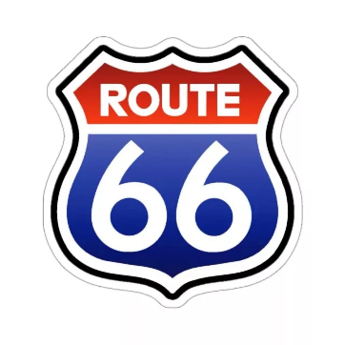

Design Rules
- All NGC policies and rules apply.
- The exhibitor must have solely created all entries.
- The exhibitor need not have grown plant materials in these classes.
- Only one entry may be entered in each class by each exhibitor.
- Accessories are permitted in all classes.
- No artificial plant materials may be used.
- Fruits or vegetables may be used; if cut, they must be sealed unobtrusively with plastic wrap or other sealer.
- No prepared food products are allowed in any exhibit.
- Each exhibit must contain some plant material.
- All plant material used in the design should be identified on a 3”x5” card provided by the exhibitor and included with the entry tag. Exhibitors may further title their entries if desired, with a title or an explanation on the card.
- Each Class is subdivided by age group.
- Entry tags in the Design Division will be categorized by the following colors:
  - Juniors, age 4-7 – Pink
  - Middle School, age 8-12 – Green
  - High School, age 13-18 – Purple
  - Special Needs (regardless of age) – Blue
- For additional information refer to “Design” as stated in Division II (Design) of the State Fair Standard Flower Show Schedule.

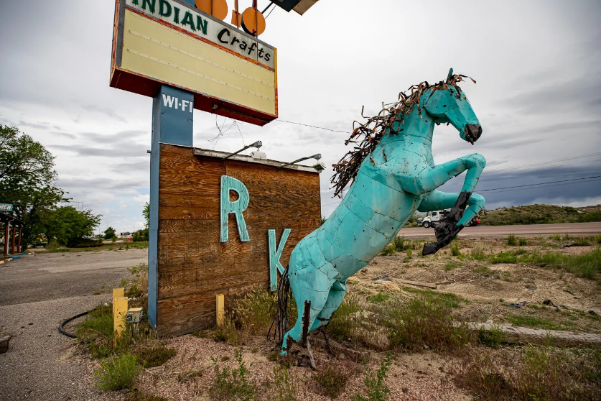

Section B
Design

“NM’s Rt 66, The Mother Road”

“Roadside Attractions”

Class 12-14

This Section is eligible for one (1) Youth Top Exhibitor Award, fifteen (15) State Fair Special Awards one for each category.

Class 12. “Rt 66 Road Sign”– Celebration Cake – A creative design containing fresh, dried or a combination of plant material made to look like a cake that is a celebration of the Route 66 Road sign. Must be displayed on some type of base, such as a tray, platter, plaque, etc., provided by the exhibitor, which can be moved easily. No larger than 14” wide.

Categories:

4-7 years

8-12 years

13-18 years

Any age special needs

Class 13. “Memento of Route 66” – Creative Design – Using fresh, dried, or a combination of plant material, create a design representing mementos of something along route 66, which is New Mexico’s Mother Road. No larger than 16” wide in any direction except for height.

Categories:

4-7 years

8-12 years

13-18 years

Any age special needs

Class 14. “Ranch Kitchen Turquoise Horse” – Animal – Using fruits and/or vegetables and/or flowers and/or seeds, create a Horse. Must be displayed on some type of base, such as a tray, platter, plaque, etc., provided by the exhibitor, which can be moved easily. No larger than 16” wide in any direction except for height.

Categories:

4-7 years

8-12 years

13-18 years

Any age special needs

